Processing Steps

* **General**
  + BTs will be found in the Fees section
  + IGNORE
    - Payment Processing fees
    - $0 BTs
    - 1% Gross Profit BT
    - BT for “Any registrations that are sub $100 will be charged at 2%”
  + If a contract has “Minimum annual registrations,” we will need to turn on Usage AI (instructions below)
* **Discount**
  + Use the net price after discounts for BTs
* **Item Name:** Use the label of the fee but keep it clean and concise (e.g., "Licensing Fee," "Website Hosting," "Youth Team Fee").
* **Quantity:** 
  + For licensing fees, can use the number of players if listed
    - E.g. “$1,200 CAD annually for the first 1,000 individual player registrations” would be a flat $1200
* **Licensing Fees**
  + Can have a few different set ups
    - Flat annual fee -> flat price
    - Flat annual fee + overage -> flat price for annual fee + tired usage BT for the overage
    - Tiered per player registration -> tiered usage BT (no flat fee needed)
* **Service and Billing Start Date:**
  + Use the "Effective Date" in the contract
  + If there are multiple years of fees, use the start date of that BT (Year 1 BT use effective date, Year 2 BT use 12 months after effective date)
* **Months of Service:**
  + If multiple years of fees are listed, follow that cadence
  + Look for a contract termination date to determine length
  + Default to 12 if nothing available
* **Frequency:**
  + Use the billing cadence listed in the header of the fees section
    - “Licensing fees, invoiced quarterly, of:”
    - “Additional fees of, invoiced annually based on actual use:”
  + One-time setup fees should have frequency set to None.
  + There will also be instructions in the Invoicing & Billing section but the headers in the fees section override
* **Additional Usage Terms:**
  + “No-Show Fee”
    - If you see this clause: “Failure to attend a scheduled training session without prior notice, will result in a fee of $100 payable by the Customer prior to any future training scheduling.”
    - Set it up as a usage fee titled “No-Show Fee” with the corresponding event monthly in arrears
* **Net Terms:** Default to 30 unless net terms are listed
* **Usage AI (for minimum annual registrations):**
  + “Minimum annual registrations quantity of 1,200 players”
    - [Example 1](https://garage.tabsplatform.com/prod/contracts/5ccc3000-ebd0-492c-8a49-1a2cb57999b0/terms/revenue)
    - [Example 2](https://garage.tabsplatform.com/prod/contracts/f3fe018e-6b8e-420d-9dd7-a3b665f99c16/terms/revenue)

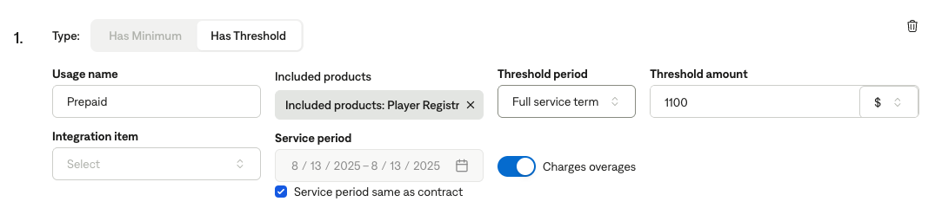

* + Make sure to first create a flat BT for the minimum amount in $, not number of players. If multiple years, set for multiple years
  + Has Threshold
  + Included products: the per player rates usage BT
  + Threshold amount should be the $ amount representation of the minimum
    - If the minimum is a player amount, multiply the player # by the per player fee
  + Select charges overages
  + Threshold period is full service term